4 things to look before pacing a trade-

**Market structure-** check krein is it in-

Uptrend, downtrend or sideways

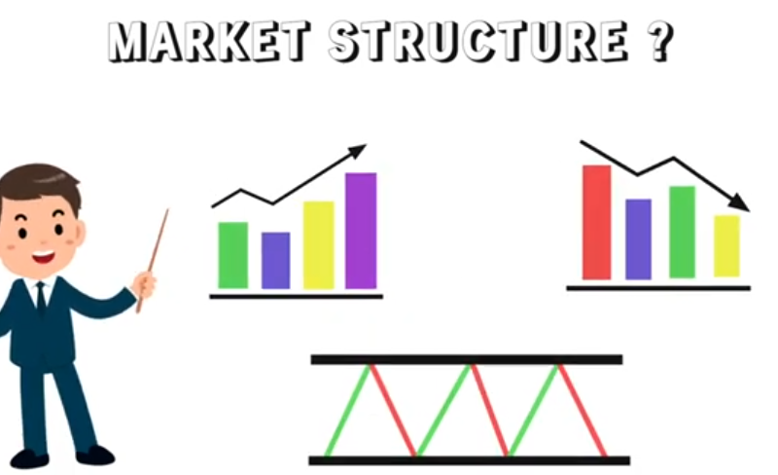

* We have not only to check the current time frame, ek time frame upar aur ek timeframe niche dono dekhein.
* 1hr ke saath 4hr time frame- dono mai agar market uptrend hai to buying ki opportunity hai matlb.
* Agar dono time mai downtrend hai to selling ki opportunity hai matlb.
* Agar side trend hai to support par buy krenge aur resistance par sell.
* Agar 1 hr time frame mai market upar hai aur 4 hr mai niche hai, tab hum ek aur upar wala time frame dekhenge. Maximum current se 2 upar time frame dekhne hote hain bas.
* Agar chart confusing hai to don’t trade.

**Area of value:**

Jab hum trend identify kr lete hain, to humein value area identify krna hota hai. To area of value support and resistance ho skta hain. Ex- agar market uptrend mai hain to hum price ka previous key level aane ka wait kr skte hain, jo breakout ke baad support ban gya hai .

Hum wait kr skte hain price kaa, kisi specific moving avg par retest krne kaa, price ka trendline approach krne ki aur bhi cheezein hain like-

* Supply and demand zone
* Pivot point

Iska matlb hume best price ka wait krna chahiye, jo value area ko approach kre.

Entry trigger- jab price area of value ko approach krta hai, tab immediately koi trade nhi leni. Kuch sign aise mile jo hume indicate krein ki hum jo trade lene wale hain wo hamare favour mai ho. Ye entry trigger ek candlestick pattern bhi ho skta hain.

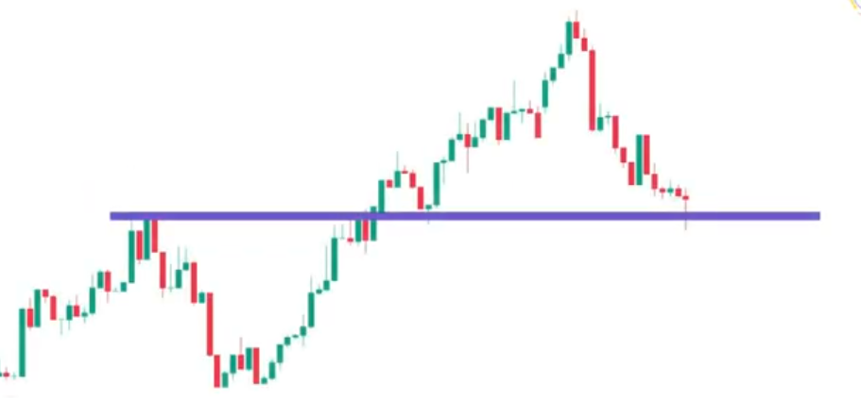

Agar price support par hai to yha bullish engulfing candle bane.



Ya specific trading strategy dekh skte hain, jismai hum dekhenge RSI, MACD

Stochastic.

Ya hum confluence ke base par trade le skte hain. Jb multiple factors same level par milte hain. Ex-

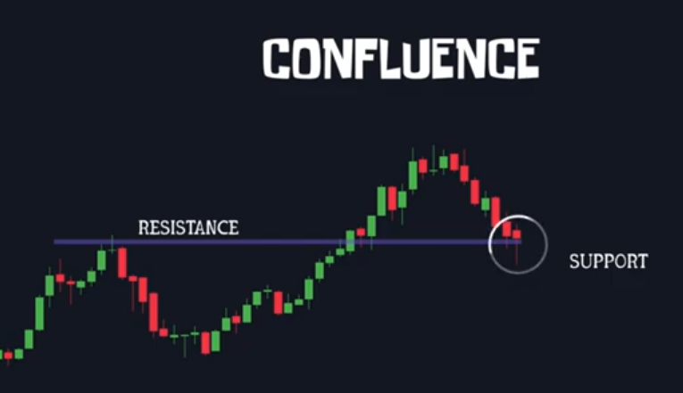

Yha ek previous resistance level hai jo breakout ke baad support ban chukka hain. Yha hamare pass 50 EMA ka support bhi hai, ise hum confluence bolte hain, jhan multiple factors same point par mil jaate hain.

Yha hum fibonnachi retracement ka bhi use kr skte hain, confluence ke roop mai, jismai hum 50% level 61.8% level ko observe krte haain. Aur yha hum candlestick pattern ko bhi dekhte hain.

Agar 3 se 4 point same point par signal dete hain to hamare winning ke chance jada hote hain.

Jab hamare pass valid trigger point hota hain entry lene ke liye to hum next step lete hain exit kaa.

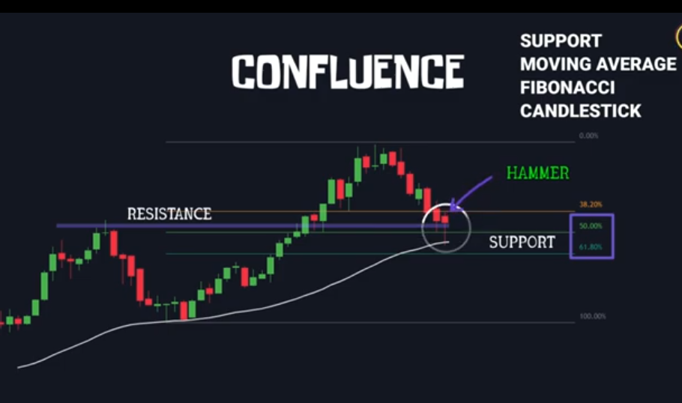

**Exit ko hum 2 part mai divide kr skte hain-**

When to exit if wrong- hamara stop loss aisi jagah hona chahiye agar price us level ko approach kre to hamara trade setup invalid ho jaaye. For ex- hum uptrend ke time support par buy krte hain, tb hamara stop loss is support ke niche hoga. Kyunki agar hamara trade support level ko break krta hain iska matlb ki hamari trade support ko respect nhi kr rhi, price isse bhhi niche jaa skta hain.

Simply jab price aapke trading setup ko invalid banade wha aap exit ho jaao. Trading mai risk management jaruri hai.

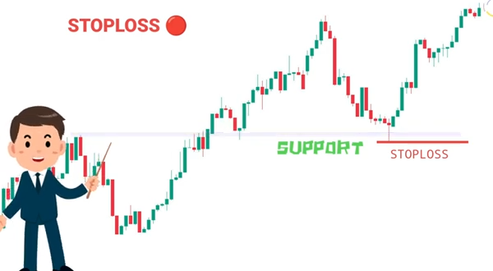

When to exit if right-

Agar market uptrend mai hai to hum trailing stoploss use kr skte hain.

Agar market range mai hai, aur support pe buy kiya, to price ke resistance par phuchne se pehle hume exit hona hain

Agar hum trending market mai trade lete hai to hum bade timeframe ko dekhenge ki khi yha koi key level to nhi hain, kyunki bade time frame ka key level chote time ke hurdle ka kaam krta hain.

Basic terms of stock market-

Bull market- share ka price bad rha ho aura aage bhi expect badne ka ho to bull market hota hain.

Bear market- jab price gir rha ho aura age bhi girne ka andesha ho to bear market hota hai.

Sideways market- jab share ka price nag ire na bade ek range mai move kre to sideways hota hina

Trend – jab stock ki movement kisi particular side mai ho, like upar ki taraf uptrend niche ki taraf downtrend

Intraday- share ko jis din kharida usi din bechana

Delivery- jab kisi share ko ek din se jada din hold krein to delievery.

Liquidity- hume batati hai ki kisi stock mai kitne amount mai buy aur selling hoti hain.

Volatility- eke measure hota hain jo batata hai ki kisi time period mai stock ka price kitna upar aur kitna niche gya.

OHLC- Open, high, low, close. Ek candle 4 price se milkar banti hain

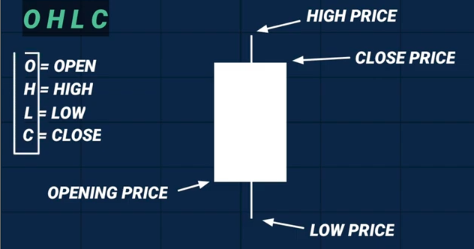

IPO- initial public offer- first time share issue krna IPO kehlata hain.

Portfolio-

Index- market capatilisation ke hisaab se similar stocks ko index kr diya jaata hain like nifty 50, sensex (top 30 stocks), banknifty

Ask price- price at which seller is willing to sell

Bid price- price at which a buyer ready to buy

Ask bid spread- difference btw bid and ask price.

**Intraday trading:**

**6 Golden rule for intraday:**

Rule1: trade like a robot. Control on emotions like (revenge trading, control to loss),

Rule2- set your daily limit loss, ham eek daily limit rakhna hai ki isse jada loss nhi krenge. Ek professional trader hamesha dekhta hai ki mera daioy limit loss kitna hona chahiye. Matlb loss lene ka risk.

Rule3: treat stoploss as cost of doing business

Rule4: don’t overtrade. Kam trade le aur quality trade le.

Rule5: keep away from social media while trading.

Rule6: maintain a trading Journal.